Continuous Assessment 

Student Name (Student ID)

Engineering and Evaluating Artificial Intelligence - MSCAIB

School of Computing

National College of Ireland

**Table of contents**

1 Introduction 4

2. Literature Review 4

3. Methodology 4

3.1 Overview of the architecture 4

3.2 Approach to Multi-Label Classification 4

3.3 Process of design decision 5

3.4 Tools and Technologies 5

4. Design Choice 1: Chained Multi Outputs 5

4.1 Description of the method 5

4.2 Architectural Sketch 6

4.3 Components 7

4.4 Connectors 8

4.5 Data Elements 9

5. Design Choice 2: Hierarchical modelling 10

5.1 Description 10

5.2 Architectural Sketch 10

5.3 Connectors 11

5.4 Data Elements 13

5.5 Trade-off evaluation 13

6. Conclusion 14

6.1 Summary of findings 14

6.2 Final Recommendations 14

Reference list 15

**Group Contributions**

|  |  |
| --- | --- |
| **Name** | **Contribution** |
| Akhilreddy Madhireddy | Introduction and Literature Review |
| Sampathreddy Kalwa | Methodology and Chained Multi Output Architecture |
| Shaik Junaid | Hierarchical Modelling and Conclusion |

# 1 Introduction

Multi-Label Classification (MLC) is a key area in AI, helping systems to assign many labels in a single instance which helps in filtering of email, medical diagnosis as well as recommending engines. With complexity increasing in AI projects, understanding the method of MLC, performance and trend is important for developing accurate, scalable and context related solutions for real world problems.

# 2. Literature Review

Technological advancement has helped in implementation of multi-label classification (MLC) in AI projects which are also seen in past studies. Bogatinovski et al. (2022) and Lanchantin et al. (2021) has implemented a comprehensive benchmark for 26 multi label classification in 42 different datasets. This has provided valuable insights for evaluation metrics, dependencies of labels and trade - off between computational methods. The research is instrumental for selection of the model and assessment of the performance. However, Liu et al. (2021) and Wang et al. (2021) has focused on understanding the emerging trends in MLC like extreme MLC, integration of deep learning as well as limited problems of supervision. The work gives importance to future directions in terms of label sparsity and scalability thus, these studies complement each other.

# 3. Methodology

## 3.1 Overview of the architecture

The architecture that has been proposed helps to modularise the multi-label email classification system done by separating preprocessing, modelling and data encapsulation components. For this TF-IDF text transformation along with a classifier chain has been developed for prediction of the target labels. This makes sure that the design is scalable, consistent, maintainable and provides proper integration of ML models for high performance.

## 3.2 Approach to Multi-Label Classification

The method leverages a development of a structure which is chained multi-output, where one main classifier tends to predict the target variable sequentially. The predictions are based on previous labels, making sure that interdependencies are properly implemented. The system implements a unified interface for maintaining consistency along with robust extraction of features for proper multi-label classification. Thus, this method helps in delivering high accuracy and performance.

## 3.3 Process of design decision

The process of design begins with the evaluation of requirements of the system as well as reviewing prior lab implementations. Then the comparison of multi-output and hierarchical modelling has been done, understanding the scalability, maintenance and modularity of the designs. Input from stakeholders, iterative prototyping and simulation of performance helps the final architecture to meet the problems of multi-label classification properly.

## 3.4 Tools and Technologies

The project implements Python for data analysis and coding by using libraries like Pandas, Scikit-learn and Numpy for doing proper data preprocessing as well as ML. This Jupyter notebook has been used since it provides an interactive environment, while Git helps in controlling the version. Random Forest, ClassifierChain and TF-IDF have helped in delivering proper solutions, showing reproducibility. scalable and maintainable for every project.

# 4. Design Choice 1: Chained Multi Outputs

## 4.1 Description of the method

The method implemented is a chained multi - output classifier that predicts interdependent labels sequentially. Implementation of TF-IDF helps in changing text to numerical features, and a Random Forest Classifier has been developed, wrapped in a ClassifierChain predicting Type 2, Type 3 and Type 4 respectively and delivering proper predictions.

## 4.2 Architectural Sketch

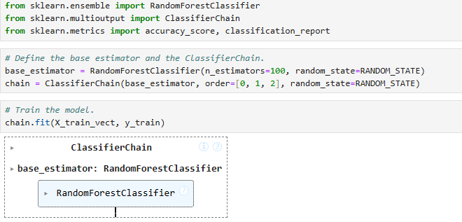

***Figure 1: Architectural sketch for Chained Output***

The above figure shows the architectural sketch for the Chained Output using Random Forest Classifier. The model is integrated within a ClassifierChain making sure that the sequential predictions of Type 2, Type 3 and Type 4 are done. By using TF-IDF, the feeding of the features at each output target into next has been done consistently thus interlinking classification and helps in fostering modularity. The classifier chain structure is to combine multiple Random Forest classifiers, and in each iteration, it always makes a prediction and passes the result to the next model as an extra feature, thus being able to model the relationship between the labels based on this condition. It is inherently modular, as it involves one model per label and is interpretable because each Random Forest classifier can be checked for feature importance. Random Forest is a strong individual learner that is immune to the noise input and helps check overfitting using the concept of averaging. However, this sequential setup can have the problem of error accumulations: any mistakes made in an early prediction tends to accumulate or propagate to the next stages. In addition, one notices dependence on the order in which the labels are used.

## 4.3 Components

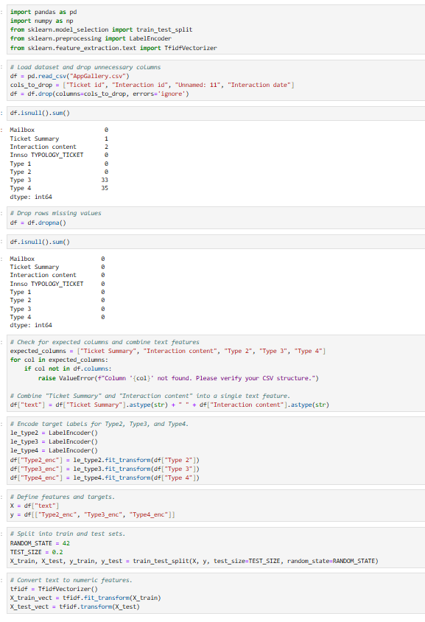

***Figure 2: Components for Multi chain classification and hierarchical modelling***

The above figure shows the components which are common for both the multi-chain classification and hierarchical modelling. The first components are data ingestion, cleaning and transforming, merging and dropping columns are the second components. The third component includes converting Type 2, Type 3 and Type 4 into numeric values using Label Encoding which is then used for data splitting into training and testing for classification making sure that separate modules are implemented having a consistent data flow.

## 4.4 Connectors

|  |
| --- |
|  |
|  |

***Figure 3: Connectors of Multi Chained Classifier based on accuracy and classification report***

This figure helps to understand that the ClassifierChain predictions flow the classification report and accuracy, showing the output of the model with interpretive metrics. This connector helps to change the raw numeric results properly into key insights. The accuracy falls for Type 3 (88.89%) and Type 4 (77.78%) showing rising complexity. The classification report shows uneven precision and recall showing some errors indicating the complexity in doing deeper prediction of the labels.

## 4.5 Data Elements

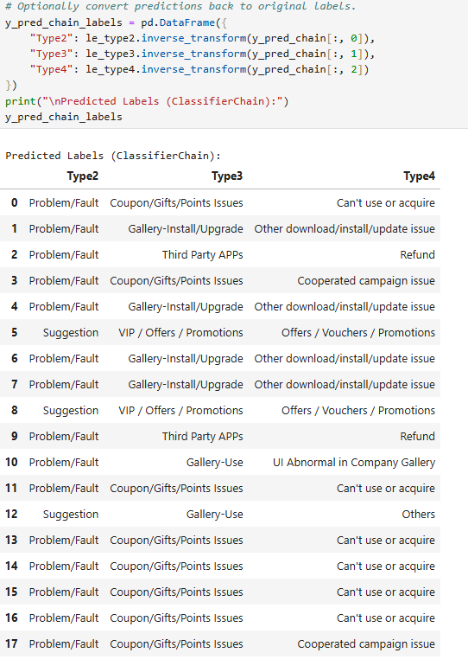

***Figure 4: Predicted data elements***

The figure shows the predicted data elements which are Type 2, Type 3 and Type 4 which are restored to their original categories. The numeric output of the rows is converted back showing consistency the raw model output to labels which can be easily interpreted. This shows that the pipeline of the multi-label classification is important.

# 5. Design Choice 2: Hierarchical modelling

## 5.1 Description

Design choice 2 implements a hierarchical modelling method, training the classifier for each label separately in a sequence. First Type 2 is predicted in the dataset then for each predicted type 2 class, the type 3 model is trained which is followed by Type 4. This approach provides a proper prediction for each stage, but the complexity increases.

## 5.2 Architectural Sketch

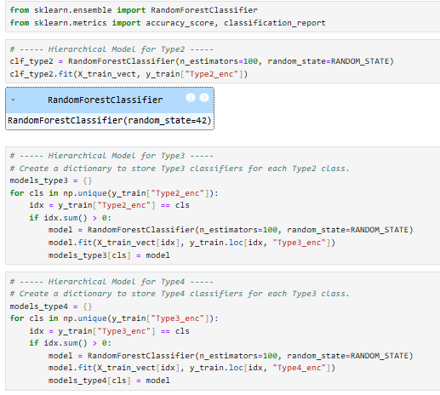

***Figure 5: Architectural sketch for hierarchical modelling***

The architectural sketch includes training of one classifier for predicting Type 2 for the entire dataset. Then for every Type 2, a specialised model for Type 3 is training, the same pattern is followed for Type 4. This forms a hierarchical and cascading pipeline for each label. Please provide critical analysis of this architectural sketch in 100 words. Proper back-end architecture should be stated. The system divides classification operations by stages which operate on specific labels through their unique specialisation where, Random Forest model predicts Type2. Each Type3 model receives training using exclusive datasets which correspond to the predictions of Type2 models. The training of Type4 models proceeds in the same way as Type3 models. The structured pipeline establishes label dependencies though it focuses its different stages on specific subsets of data leading to potential accuracy improvement. Operating this method requires numerous models that lead to extensive training needs while also causing increased system complexity. Most reliable back-ends divide their operations into three distinct modules which handle data preparation and model creation together with inference organization. The system architecture promotes maintenance functions and maintains well-defined data paths and standardised methods for handling filtered subset data.

## 5.3 Connectors

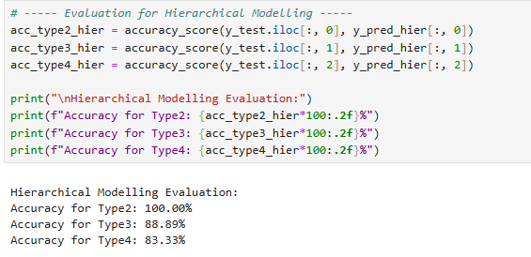

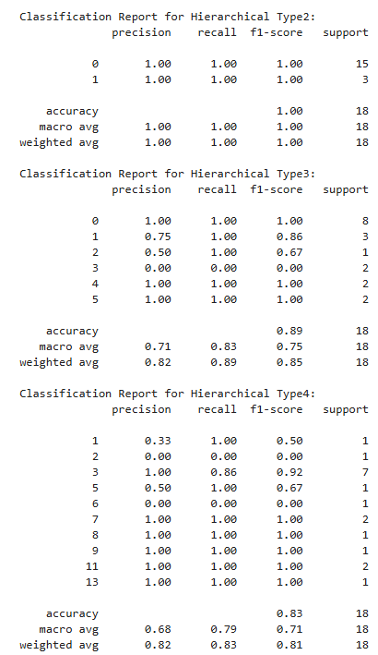

***Figure 6: Connectors for hierarchical modelling***

The above figure shows that the prediction of each state is connected to the next, filtering data based on predicted labels. The perfect accuracy for Type 2 shows specialised Type 3 and Type 4 classifiers, even though the performance drops. This shows the high capability of the hierarchical connectors’ for doing proper training despite having some errors.

## 5.4 Data Elements

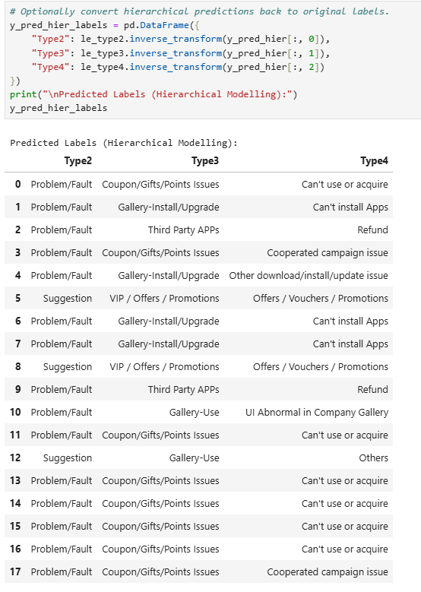

***Figure 7: Data Elements of hierarchical modelling***

The figure shows the final predictors for each type, changing the numeric predictions to categories which can be interpreted. The hierarchical pipeline provides specialised results, showing the dependency of the data elements on prior label classification in a hierarchical approach.

## 5.5 Trade-off evaluation

The implementation of chained multi output is simpler, but the errors increase which reduces the accuracy of Type 4. Hierarchical modelling implements specialised classifiers for the predicted labels, improving the accuracy but the complexity increases. Observed metrics show a trade-off among chained and fine-grained classification properly.

# 6. Conclusion

## 6.1 Summary of findings

The report concludes that the ClassifierChain provides strong Type 2 accuracy but reduces the performance of other labels. Conversely, hierarchical modelling provides specialised prediction for each label, improving the metrics but complexity also increases.

## 6.2 Final Recommendations

Based on the analysis, chained multi-output is recommended since this is simple and provides a consistent interface if propagation of error is minimal. However, for imbalance dataset and when specialised predictions are needed to be done, hierarchical modelling is expected to be used. Also, more tuning and validation is important for improving the performance for each label.

# Reference list

Bogatinovski, J., Todorovski, L., Demoski, S. and Kocev, D. (2022). Comprehensive comparative study of multi-label classification methods. *Expert Systems with Applications*, 203, p.117215. doi: https://doi.org/10.1016/j.eswa.2022.117215.

Lanchantin, J., Wang, T., Ordonez, V. and Qi, Y. (2021). General Multi-Label Image Classification with Transformers. *Thecvf.com*, [online] pp.16478–16488. Available at: http://openaccess.thecvf.com/content/CVPR2021/html/Lanchantin_General_Multi-Label_Image_Classification_With_Transformers_CVPR_2021_paper.html [Accessed 26 Mar. 2025].

Liu, W., Wang, H., Shen, X. and Tsang, I.W. (2021). The Emerging Trends of Multi-Label Learning. *IEEE Transactions on Pattern Analysis and Machine Intelligence*, [online] pp.1–1. doi: https://doi.org/10.1109/TPAMI.2021.3119334.

Wang, H., Liu, W., Bocchieri, A. and Li, Y. (2021). Can multi-label classification networks know what they don’t know? *Advances in Neural Information Processing Systems*, [online] 34, pp.29074–29087. Available at: https://proceedings.neurips.cc/paper_files/paper/2021/hash/f3b7e5d3eb074cde5b76e26bc0fb5776-Abstract.html [Accessed 26 Mar. 2025].